Curvilinear Shapes
# Source: AI Source: Provided by: [Data Path: Persons Table -> ID Column: 1, Name_En Column: Motasem Essam] -> From: [ChatGPT] on [7/25/2026]
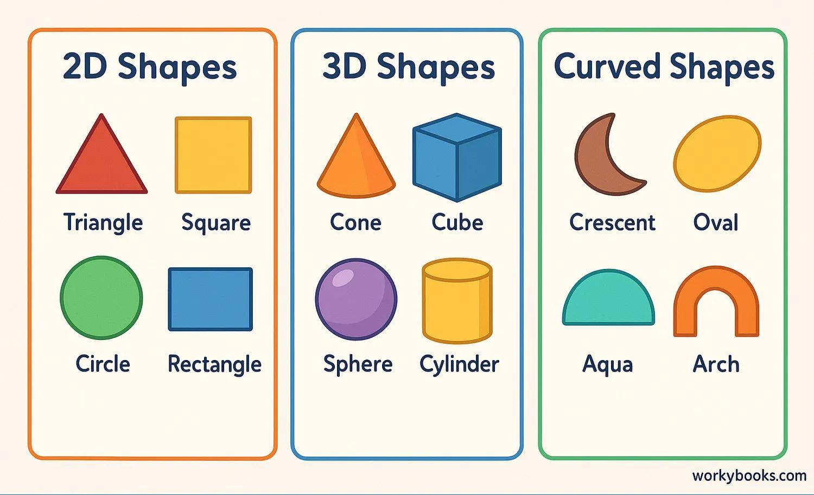
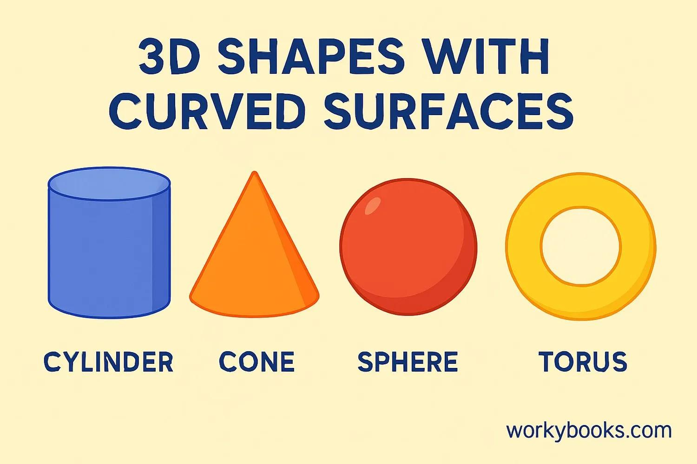
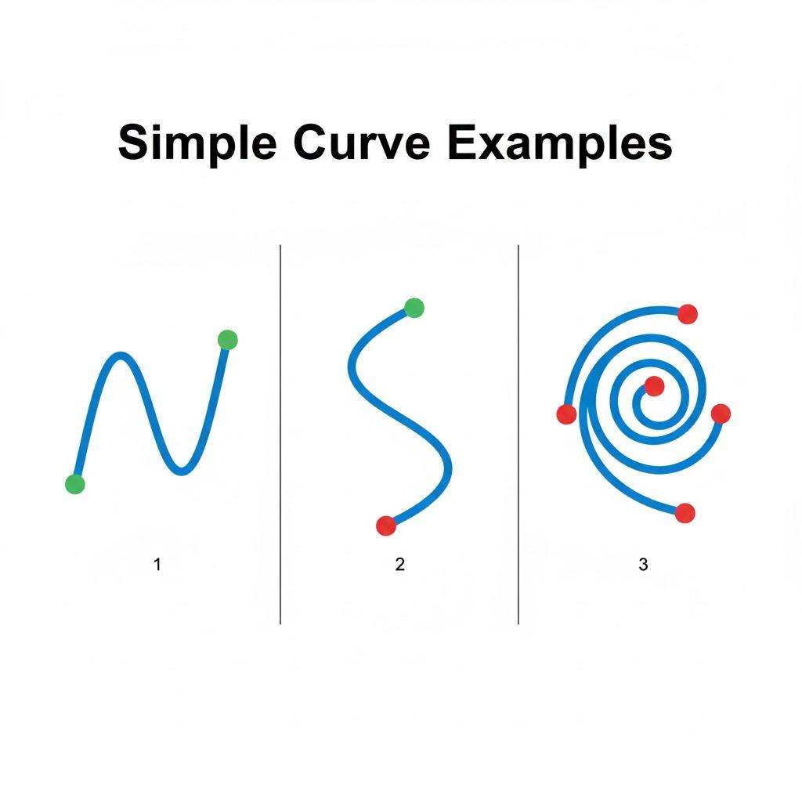
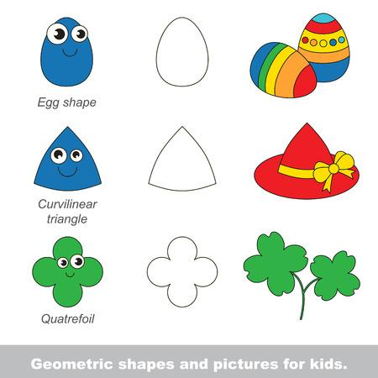
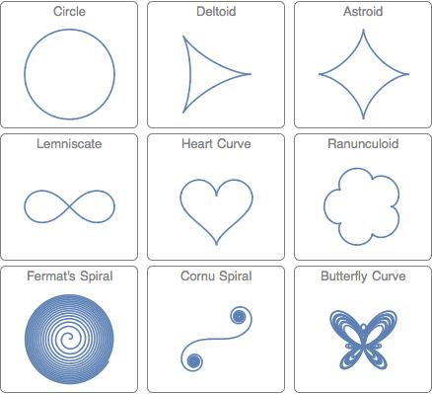
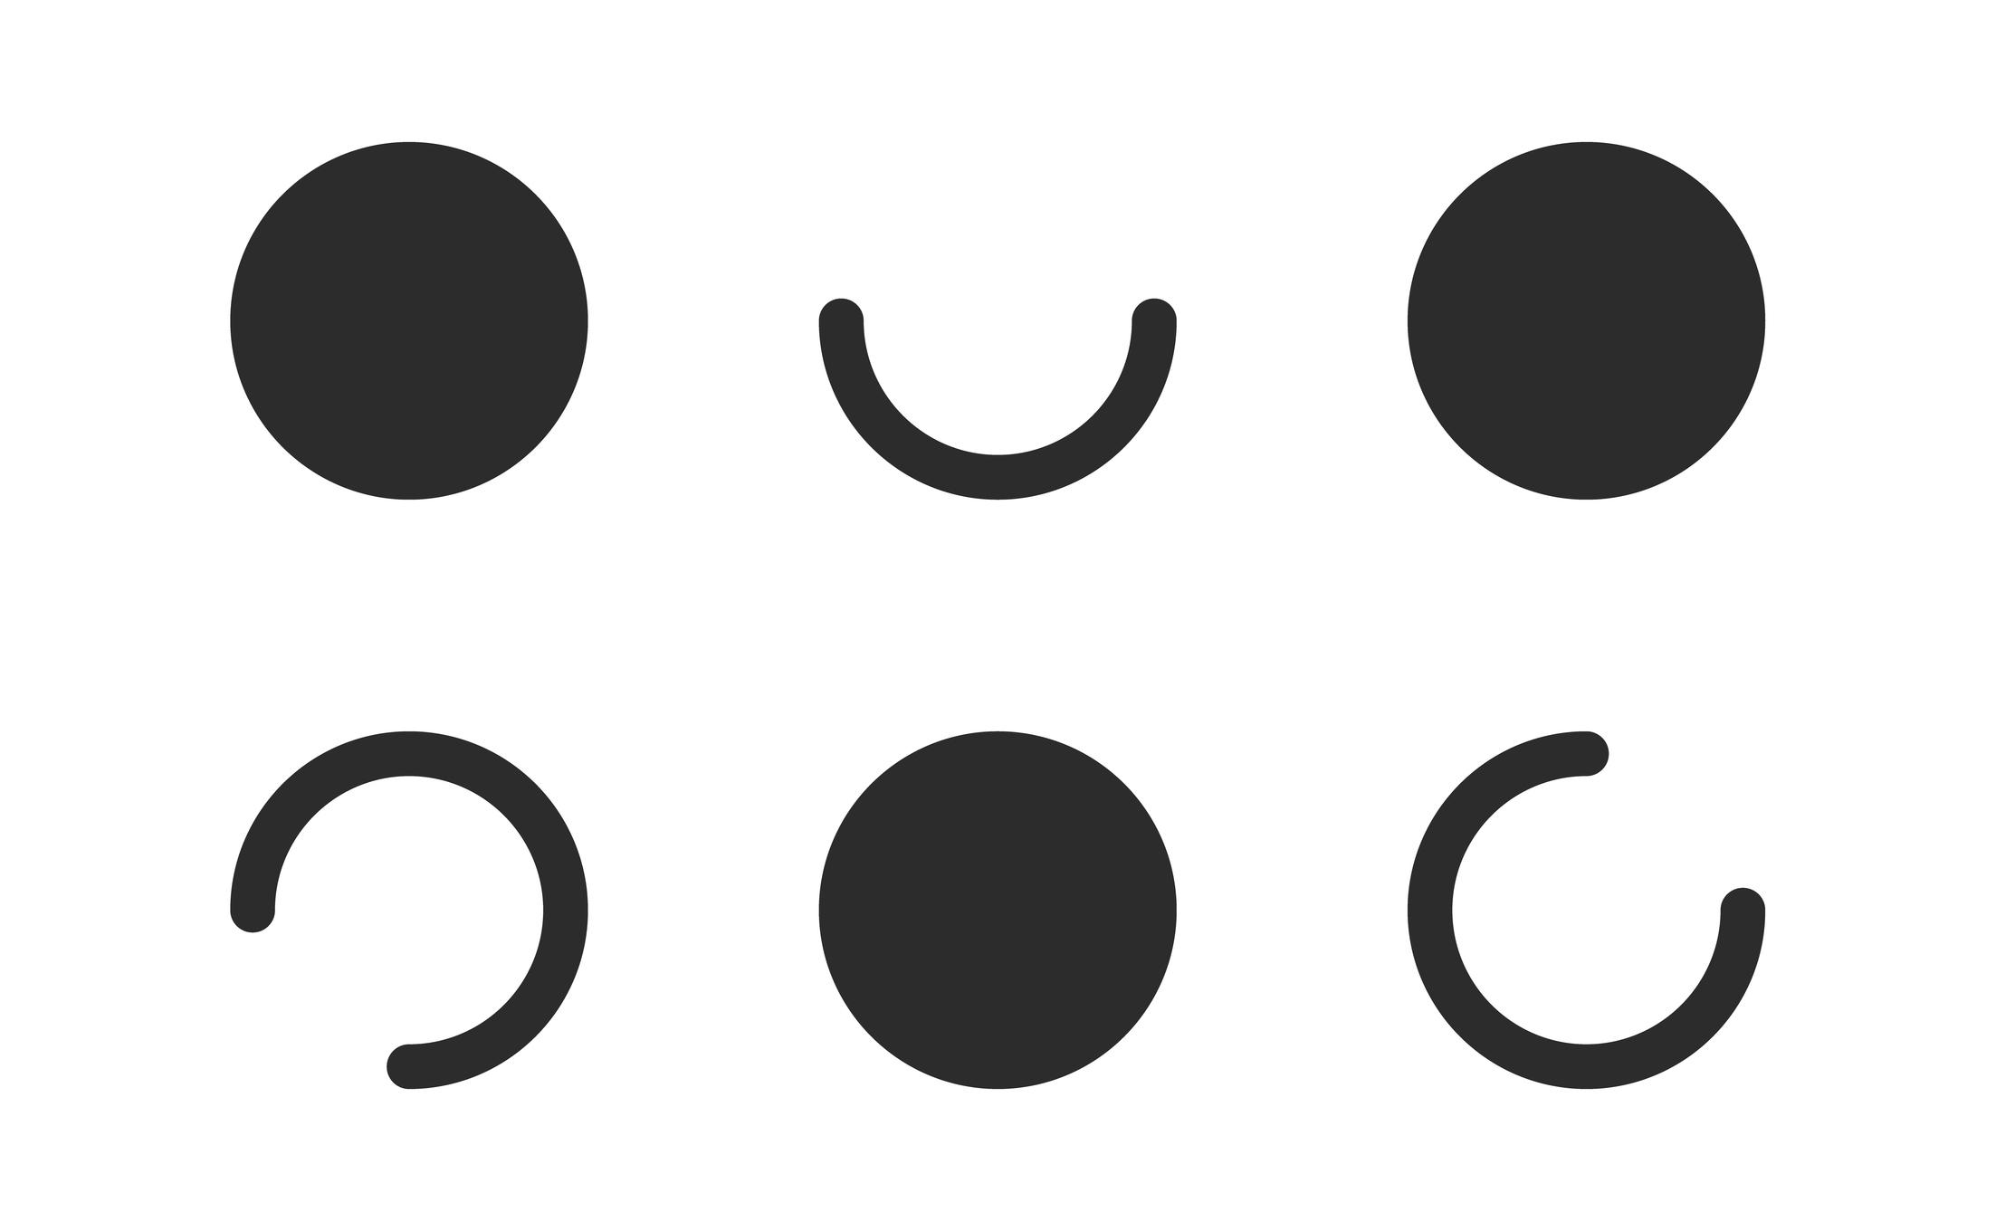

Definition
# Source: AI Source: Provided by: [Data Path: Persons Table -> ID Column: 1, Name_En Column: Motasem Essam] -> From: [ChatGPT] on [7/25/2026]
Curvilinear Shapes are shapes whose boundaries consist primarily of curved lines or curves rather than only straight-line segments.
The word curvilinear means “bounded or formed by curves.”
A curvilinear shape may be formed from:
- Circular arcs
- Elliptical arcs
- Smooth curves
- Irregular curves
- Wavy curves
- Other curved boundary segments
A shape may contain both straight and curved portions, but when its curved boundary is a defining feature, it can be described as curvilinear.

Fundamental Concept
# Source: AI Source: Provided by: [Data Path: Persons Table -> ID Column: 1, Name_En Column: Motasem Essam] -> From: [ChatGPT] on [7/25/2026]
The fundamental distinction is between linear and curvilinear boundaries.
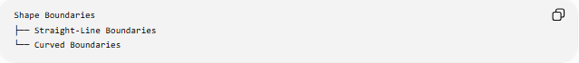
Shape Boundaries
├── Straight-Line Boundaries
└── Curved Boundaries
A polygon, for example, is bounded entirely by straight-line segments.
A curvilinear shape instead has one or more curved portions forming its boundary.
Example
A circle is a curvilinear shape because its entire boundary is a curve.
A shape formed from:
- two straight segments
- one semicircular arc
also has a curvilinear boundary.

Main Characteristics
# Source: AI Source: Provided by: [Data Path: Persons Table -> ID Column: 1, Name_En Column: Motasem Essam] -> From: [ChatGPT] on [7/25/2026]
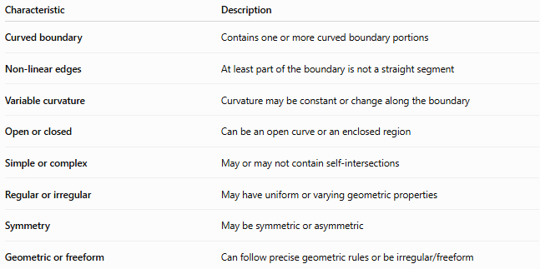
Characteristic | Description
Curved boundary | Contains one or more curved boundary portions
Non-linear edges | At least part of the boundary is not a straight segment
Variable curvature | Curvature may be constant or change along the boundary
Open or closed | Can be an open curve or an enclosed region
Simple or complex | May or may not contain self-intersections
Regular or irregular | May have uniform or varying geometric properties
Symmetry | May be symmetric or asymmetric
Geometric or freeform | Can follow precise geometric rules or be irregular/freeform

Basic Structure
# Source: AI Source: Provided by: [Data Path: Persons Table -> ID Column: 1, Name_En Column: Motasem Essam] -> From: [ChatGPT] on [7/25/2026]
A curvilinear shape can be organized according to the type of curve forming its boundary:
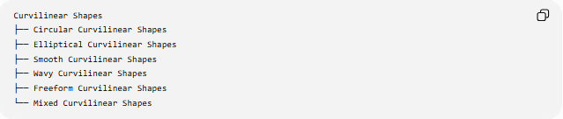
Curvilinear Shapes
├── Circular Curvilinear Shapes
├── Elliptical Curvilinear Shapes
├── Smooth Curvilinear Shapes
├── Wavy Curvilinear Shapes
├── Freeform Curvilinear Shapes
└── Mixed Curvilinear Shapes
These categories can overlap.
For example, a shape can be:
Closed + Curvilinear + Symmetric + Circular

Types of Curvilinear Shapes

1-Circular Curvilinear Shapes
# Source: AI Source: Provided by: [Data Path: Persons Table -> ID Column: 1, Name_En Column: Motasem Essam] -> From: [ChatGPT] on [7/25/2026]
Shapes whose curved boundaries are formed from circles or circular arcs.
Examples include:
- Circle
- Semicircle
- Circular sector
- Circular segment
- Annulus
- Shapes bounded by multiple circular arcs
For a circle:
$${\left(x-h\right)}^{2}+{\left(y-k\right)}^{2}=r^{2}$$
where:
- $\left(h , k\right)$is the center
- $r$is the radius

2-Elliptical Curvilinear Shapes
# Source: AI Source: Provided by: [Data Path: Persons Table -> ID Column: 1, Name_En Column: Motasem Essam] -> From: [ChatGPT] on [7/25/2026]
Shapes whose boundaries contain ellipses or elliptical arcs.
An ellipse centered at the origin can be represented by:
$$\frac{x^{2}}{a^{2}}+\frac{y^{2}}{b^{2}}=1$$
where:
- $a$is the semi-major or semi-minor axis
- $b$is the other semi-axis
An ellipse differs from a circle because its curvature generally changes around the boundary.

3-Smooth Curvilinear Shapes
# Source: AI Source: Provided by: [Data Path: Persons Table -> ID Column: 1, Name_En Column: Motasem Essam] -> From: [ChatGPT] on [7/25/2026]
Shapes whose boundaries change direction smoothly without sharp corners.
A smooth curve can be represented parametrically as:
$$r\left(t\right)=\left(x , \left(t\right)y\left(t\right)\right)$$
with continuously varying direction.
Examples include:
- Smooth blobs
- Rounded forms
- Smooth closed curves
- Flowing curves

4-Wavy Curvilinear Shapes
# Source: AI Source: Provided by: [Data Path: Persons Table -> ID Column: 1, Name_En Column: Motasem Essam] -> From: [ChatGPT] on [7/25/2026]
Shapes containing wave-like curved boundaries.
A regular wave can be modeled using:
$$y=Asin⁡\left(Bx+C\right)+D$$
where:
- $A$controls amplitude
- $B$controls frequency
- $C$controls phase
- $D$controls vertical displacement
Wavy curvilinear shapes can be regular or irregular.

5-Freeform Curvilinear Shapes
# Source: AI Source: Provided by: [Data Path: Persons Table -> ID Column: 1, Name_En Column: Motasem Essam] -> From: [ChatGPT] on [7/25/2026]
Shapes whose boundaries consist primarily of curves but do not follow a fixed standard geometric form.
They may contain:
- Irregular curves
- Variable curvature
- Unequal bulges
- Irregular indentations
- Asymmetric contours
These overlap strongly with Freeform Curved Shapes.

6-Mixed Curvilinear Shapes
# Source: AI Source: Provided by: [Data Path: Persons Table -> ID Column: 1, Name_En Column: Motasem Essam] -> From: [ChatGPT] on [7/25/2026]
Shapes whose boundaries contain several different types of curves.
For example:
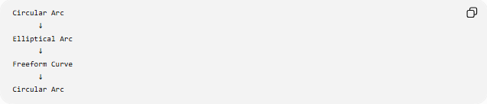
Circular Arc
↓
Elliptical Arc
↓
Freeform Curve
↓
Circular Arc
A mixed curvilinear shape does not need to use only one mathematical type of curve.

Open and Closed Curvilinear Shapes

Open Curvilinear Shapes
# Source: AI Source: Provided by: [Data Path: Persons Table -> ID Column: 1, Name_En Column: Motasem Essam] -> From: [ChatGPT] on [7/25/2026]
An open curvilinear shape is a curved path with two endpoints.
$$r\left(a\right)≠r\left(b\right)$$
Examples include:
- Curved lines
- Arcs
- Wavy paths
- Open freeform curves
An open curve does not enclose a region by itself.

Closed Curvilinear Shapes
# Source: AI Source: Provided by: [Data Path: Persons Table -> ID Column: 1, Name_En Column: Motasem Essam] -> From: [ChatGPT] on [7/25/2026]
A closed curvilinear shape returns to its starting point:
$$r\left(a\right)=r\left(b\right)$$
It can therefore enclose a region.
Examples include:
- Circles
- Ellipses
- Closed organic curves
- Curvilinear regions bounded by several arcs
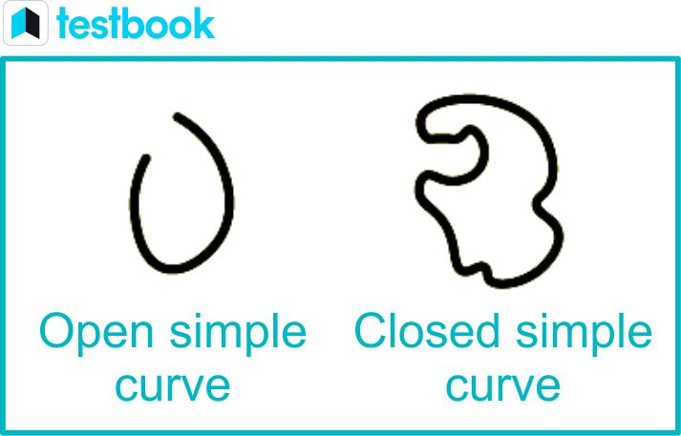
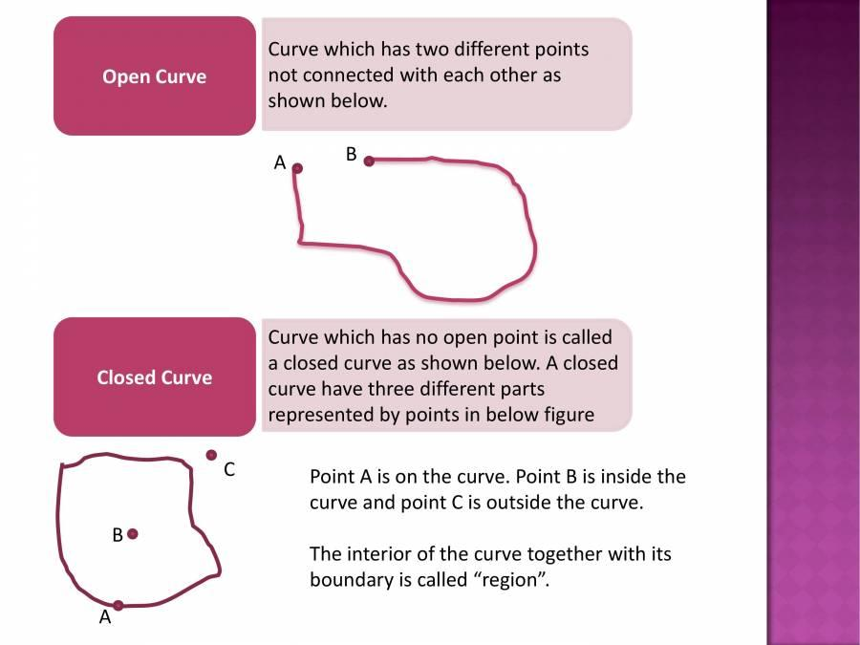
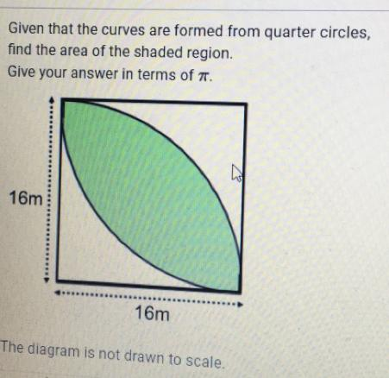
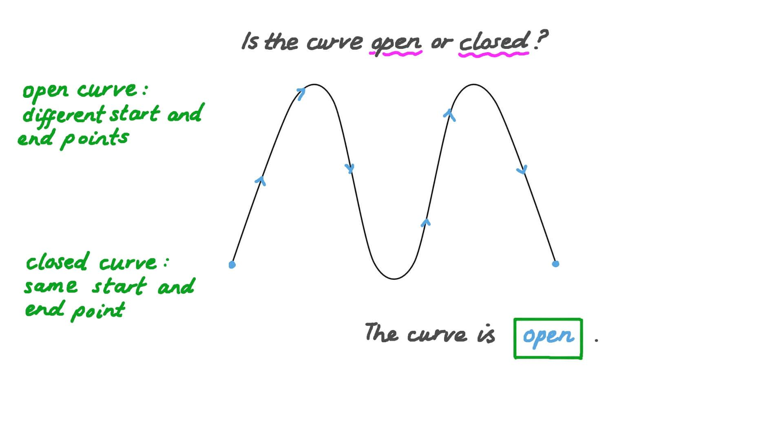

Curvilinear Shapes and Curvature
# Source: AI Source: Provided by: [Data Path: Persons Table -> ID Column: 1, Name_En Column: Motasem Essam] -> From: [ChatGPT] on [7/25/2026]
Curvature measures how rapidly the direction of a curve changes.
For a function:
$$y=f\left(x\right)$$
the curvature is:
$$κ=\frac{∣f^{''}\left(x\right)∣}{{\left(1+{\left[f^{'}\left(x\right)\right]}^{2}\right)}^{3/2}}$$
A circle has constant curvature:
$$κ=\frac{1}{r}$$
where $r$ is its radius.
For many other curvilinear shapes, curvature varies from point to point.
This gives a useful distinction:
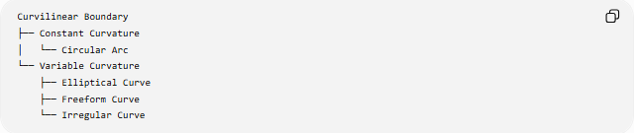
Curvilinear Boundary
├── Constant Curvature
│ └── Circular Arc
└── Variable Curvature
├── Elliptical Curve
├── Freeform Curve
└── Irregular Curve

Mathematical Representation
# Source: AI Source: Provided by: [Data Path: Persons Table -> ID Column: 1, Name_En Column: Motasem Essam] -> From: [ChatGPT] on [7/25/2026]
Curvilinear shapes can be represented in several ways.
Cartesian representation
$$y=f\left(x\right)$$
Parametric representation
$$x=x\left(t\right), y=y\left(t\right)$$
or:
$$r\left(t\right)=\left(x , \left(t\right)y\left(t\right)\right)$$
Polar representation
$$r=f\left(θ\right)$$
The appropriate representation depends on the geometry of the curve.

Arc Length
# Source: AI Source: Provided by: [Data Path: Persons Table -> ID Column: 1, Name_En Column: Motasem Essam] -> From: [ChatGPT] on [7/25/2026]
For a smooth curve $y=f\left(x\right)$, the arc length from $x=a$to $x=b$is:
$$L=\int_{a}^{b}{\sqrt{1+{\left(\frac{dy}{dx}\right)}^{2}}} dx$$
For a parametric curve:
$$L=\int_{a}^{b}{\sqrt{{\left(\frac{dx}{dt}\right)}^{2}+{\left(\frac{dy}{dt}\right)}^{2}}} dt$$
This is the curved analogue of measuring the length of a straight segment.

Area of Curvilinear Shapes
# Source: AI Source: Provided by: [Data Path: Persons Table -> ID Column: 1, Name_En Column: Motasem Essam] -> From: [ChatGPT] on [7/25/2026]
A closed curvilinear shape can enclose an area.
For a suitable closed parametric boundary:
$$A=\frac{1}{2}\oint{(}\left.x dy-y dx\right)$$
For some special curvilinear shapes, simpler formulas are available.
Circle
$$A=πr^{2}$$
Ellipse
$$A=πab$$
Circular sector
$$A=\frac{θ}{2}r^{2}$$
when $θ$is measured in radians.
Annulus
$$A=π\left(R^{2}-r^{2}\right)$$

Curvilinear Shapes vs Polygonal Shapes
# Source: AI Source: Provided by: [Data Path: Persons Table -> ID Column: 1, Name_En Column: Motasem Essam] -> From: [ChatGPT] on [7/25/2026]
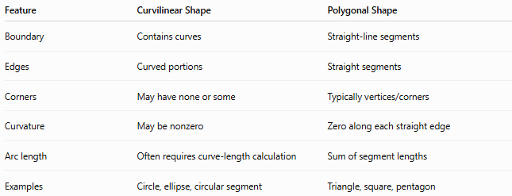
Feature | Curvilinear Shape | Polygonal Shape
Boundary | Contains curves | Straight-line segments
Edges | Curved portions | Straight segments
Corners | May have none or some | Typically vertices/corners
Curvature | May be nonzero | Zero along each straight edge
Arc length | Often requires curve-length calculation | Sum of segment lengths
Examples | Circle, ellipse, circular segment | Triangle, square, pentagon
A circle is therefore fundamentally different from a polygon even though both can enclose an area.

Curvilinear Shapes vs Freeform Curved Shapes
# Source: AI Source: Provided by: [Data Path: Persons Table -> ID Column: 1, Name_En Column: Motasem Essam] -> From: [ChatGPT] on [7/25/2026]
These terms are related but have different emphasis.
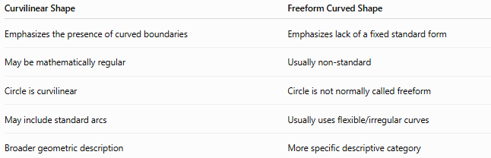
Curvilinear Shape | Freeform Curved Shape
Emphasizes the presence of curved boundaries | Emphasizes lack of a fixed standard form
May be mathematically regular | Usually non-standard
Circle is curvilinear | Circle is not normally called freeform
May include standard arcs | Usually uses flexible/irregular curves
Broader geometric description | More specific descriptive category
Therefore:
Every freeform curved shape is curvilinear if its boundary is curved, but not every curvilinear shape is freeform.

Curvilinear Shapes vs Organic Shapes
# Source: AI Source: Provided by: [Data Path: Persons Table -> ID Column: 1, Name_En Column: Motasem Essam] -> From: [ChatGPT] on [7/25/2026]
Curvilinear is primarily a geometric description.
Organic is primarily a description of appearance or natural character.
For example:
- A circle is curvilinear but not normally called organic.
- A leaf-like boundary can be both curvilinear and organic.
- An irregular mathematical curve can be curvilinear without being organic.
Thus:
$$\text{Curvilinear}≠\text{Organic}$$

Symmetry
# Source: AI Source: Provided by: [Data Path: Persons Table -> ID Column: 1, Name_En Column: Motasem Essam] -> From: [ChatGPT] on [7/25/2026]
Curvilinear shapes can have many different symmetry properties.
Reflection symmetry
$$R\left(S\right)=S$$
Examples:
- Circle
- Ellipse
- Symmetric curved shapes
Rotational symmetry
$$T_{θ}\left(S\right)=S$$
A circle has rotational symmetry for every rotation angle.
Asymmetric curvilinear shapes
Some freeform curves have no specified symmetry:
$$T\left(S\right)≠S$$
Therefore, curvature does not determine symmetry by itself.

Examples

Example 1 — Circle
# Source: AI Source: Provided by: [Data Path: Persons Table -> ID Column: 1, Name_En Column: Motasem Essam] -> From: [ChatGPT] on [7/25/2026]
A circle has a completely curved boundary with constant curvature.

Example 2 — Ellipse
# Source: AI Source: Provided by: [Data Path: Persons Table -> ID Column: 1, Name_En Column: Motasem Essam] -> From: [ChatGPT] on [7/25/2026]
An ellipse has a smooth curved boundary with generally varying curvature.

Example 3 — Circular Segment
# Source: AI Source: Provided by: [Data Path: Persons Table -> ID Column: 1, Name_En Column: Motasem Essam] -> From: [ChatGPT] on [7/25/2026]
A circular segment is bounded by a chord and a circular arc.
It is therefore a shape with both a straight and curved boundary.

Example 4 — Wavy Region
# Source: AI Source: Provided by: [Data Path: Persons Table -> ID Column: 1, Name_En Column: Motasem Essam] -> From: [ChatGPT] on [7/25/2026]
A region bounded by a wavy curve and another boundary can be described as curvilinear.

Example 5 — Freeform Curved Shape
# Source: AI Source: Provided by: [Data Path: Persons Table -> ID Column: 1, Name_En Column: Motasem Essam] -> From: [ChatGPT] on [7/25/2026]
An irregular closed curve with changing curvature is a curvilinear freeform shape.

Classification Summary
# Source: AI Source: Provided by: [Data Path: Persons Table -> ID Column: 1, Name_En Column: Motasem Essam] -> From: [ChatGPT] on [7/25/2026]
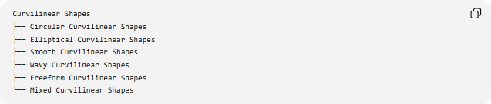
Curvilinear Shapes
├── Circular Curvilinear Shapes
├── Elliptical Curvilinear Shapes
├── Smooth Curvilinear Shapes
├── Wavy Curvilinear Shapes
├── Freeform Curvilinear Shapes
└── Mixed Curvilinear Shapes
A structural classification is:
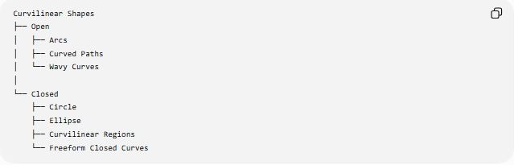
Curvilinear Shapes
├── Open
│ ├── Arcs
│ ├── Curved Paths
│ └── Wavy Curves
│
└── Closed
├── Circle
├── Ellipse
├── Curvilinear Regions
└── Freeform Closed Curves
Another useful classification is based on curvature:
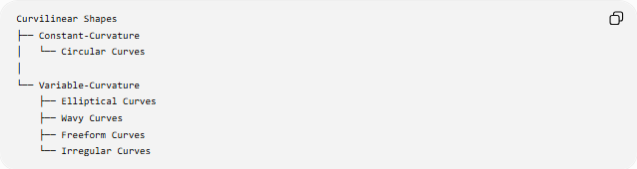
Curvilinear Shapes
├── Constant-Curvature
│ └── Circular Curves
│
└── Variable-Curvature
├── Elliptical Curves
├── Wavy Curves
├── Freeform Curves
└── Irregular Curves
These classifications describe different properties and can overlap.

Key Points
# Source: AI Source: Provided by: [Data Path: Persons Table -> ID Column: 1, Name_En Column: Motasem Essam] -> From: [ChatGPT] on [7/25/2026]
- Curvilinear Shapes have boundaries containing curved lines or curves.
- They can be open or closed.
- They may consist of one curve or several different curves.
- They include circular, elliptical, wavy, freeform, and mixed curved forms.
- Curvature may be constant or variable.
- A circle has constant curvature:
$$κ=\frac{1}{r}$$
- Many other curves have variable curvature.
- Curvilinear shapes can have measurable arc length, perimeter, area, and curvature.
- A curvilinear shape does not have to be organic or freeform.
- A shape can contain both straight and curved boundaries and still have a curvilinear component.
- Curvilinear is primarily a geometric description, not a statement about whether a shape is regular, organic, or decorative.

Conclusion
# Source: AI Source: Provided by: [Data Path: Persons Table -> ID Column: 1, Name_En Column: Motasem Essam] -> From: [ChatGPT] on [7/25/2026]
A Curvilinear Shape is a shape whose boundary is formed wholly or partly by curved lines or curves. Curvilinear geometry extends beyond straight-edged polygons to include circles, ellipses, arcs, wavy curves, freeform curves, and regions bounded by combinations of curved elements. Its defining feature is the presence of curvature in the boundary, while properties such as symmetry, regularity, and organic appearance are separate characteristics.

